Germination rates of Rudbeckia triloba after garlon chemical treatment
By: Breanna Christensen, Amelia Swiecki, Isaac Servin, Gretchen Casper, Kristi Robinson & Kim Elsenbroek
Introduction
Habitat loss and land degradation are worsening over time as a result of anthropogenic effects and invasive species choking out native species within ecosystems. Such ecological disturbances hinder the success of restoration thus calling a need for reintroduction of native species. Habitat loss can lead to poor species diversity, soil and water quality, and productivity. This is why habitat restoration is a necessity in order to increase local biodiversity and species populations (UGC Berkeley). Herbicide application is one traditional method of treatment in ecological restoration and tends to be highly effective. When there is an invasive species within an ecosystem, herbicide is used to kill the species to allow more space and resources for native plants and create a healthier, more balanced ecosystem. With herbicide use, determining best timing for application must be considered in order to treat non-native invasive species. While herbicide is usually sprayed on mature plant species, this experiment tested the application of 5% Garlon (Triclopyr) herbicide’s effect on seed germination rate of Rudbeckia triloba. In Garlon, the active ingredient is Triclopyr, which works as a growth regulator. Garlon is sprayed on the vegetation and enters through the leaves and stems and is translocated throughout the plant to the roots and non infected leaves (Arbor Chem). Garlon can remain in soil for anywhere in between 3.7 to 314 days, the average being 30 days. The length of time would depend on the soil type, environmental conditions, and formulation applied (Invasive.org).
This report addresses the effects of germination rate of native seed when herbicide is applied to the soil surface. The findings from this experiment are significant to determining whether or not it is detrimental to native seeds, pre-germination, when herbicide is applied to invasive species. The results from this experiment may help land managers decide whether or not to apply herbicide to invasives before or after seeding in native seeds, as it might affect the native plant species germination rates. Some data already exists that pertains to the negative effects of herbicide on native species. In one study, herbicide was applied to 14 different native and nonnative species that are found in North America. The results show that both native and nonnative species were affected similarly, and that, “Land managers should avoid spraying if recruitment of native species from the seedbank is a goal and should not seed directly after spraying” (Wagner, Nelson). Deciding on the best time to herbicide treat or seed in an area is difficult because of a lack of scientific evidence so our hope was to test results of native seed germination rate from an initially treated soil. Recovery of native plant communities is already difficult with prominent invasive species and oftentimes herbicide application only works in treating invasives for a short time, not leaving a significant increase in native plant species (Tyser et al. 1998; Sheley et al. 2006; Ortega & Pearson 2011; Pearson et al. 2016). In our experiment we aim to expand on these findings in hope of finding a more precise way of utilizing herbicide treatments to promote native seed growth within a community. In addition to analyzing rudbeckia germination, our experiment analyzes any weed seeds that germinated from the seedbank of the field soil collected for the experiment; this occurred because we did not have access to a soil steamer to heat kill the weed seeds prior to the rudbeckia seedling.

Keywords: Seed germination rate, herbicide, native species, ecological restoration, invasive species, habitat loss, habitat restoration, garlon, triclopyr

Materials and Methods
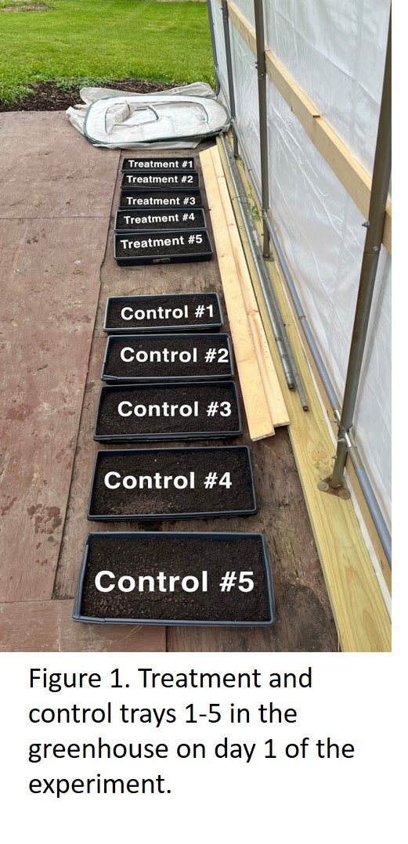
For our experiment we gathered a few needed materials. The first set of materials are three 5 gallon buckets, 10 paper envelopes, 20 planting trays, as well as labels and or masking tape and a writing utensil. In each of the 10 envelopes 50 Rudbeckia triloba seeds were collected. Other needed materials were field soil. Approximately 15 gallons of soil was collected using a spade shovel; the soil was collected from an abandoned farm field in Woodstock IL. Enough soil was collected to fill three 5 gallon buckets. . Next, field soil was sieved through a 0.80cm sieve while wearing gloves to homogenize the mixture. Sieved soil used to completely fill each experiment tray. Each tray received the study species; 50 Rudbeckia triloba seeds that were cold-stratified for approximately 3 months. The seeds were planted by spreading them by hand throughout the entire tray. After planting the trays were separated in half, 5 trays for the treatment group and the other 5 for the control group. Using tape we correspondingly labeled each tray. The last material needed for planting was water, most specifically a water source with an undefined limit. We watered each and every tray in the same way with a hose until the soil was fully saturated. Trays were watered daily on weekdays from Monday to Friday.

Creating the herbicide solution:
A 5% garlon herbicide solution was made in a 25 fl oz spray bottle. While mixing the herbicide Proper Protective Equipment (PPE) including rubber gloves, long sleeves and protective goggles were worn. For the mix, a 25 fl. oz. spray bottle is needed, as well as a funnel. For a 5% solution exactly 1.25 fl. oz. of Garlon 3a (Triclopyr) is needed; using the funnel the 1.25 fl. oz. of Garlon were poured into the bottle from a measuring cup.
Approximately 5mL of surfactant (Cidekick) was also needed and was poured into the bottle using the funnel as well. The next piece of material we used was blue dye, the kind we used was Super Signal Blue; only about 2-3 drops of the blue dye were added to the mix in the bottle. To complete the 25 fl. ounces we added water to the bottle (water can be from tap or hose), filling it to the 25 fl oz marker. The next step we took was to spray the trays we labeled for treatment with the herbicide. Placing the bottle ready to spray about 2” away from the tray 6 full sprays were delivered to each tray in the same way. Each spray was delivered apart from each other to cover the entire surface of the soil as best as possible. To conclude setting the experiment up all 10 trays were set up in a row together; each group lined up together and not randomly
After the experiment was set up trays were watered consistently. The experiment lasted 40 days, of these 40 the trays were watered only for 33 days. We watered the trays in the same manner as when the experiment was set up; with a hose until the soil was fully saturated in each tray.
ABUNDANCE ANALYSIS METHOD To analyze the results of this experiment, we collected various measurements. First, we inspected the overall abundance of each tray, counting every individual alive plant present in each tray. Then the average number of plants present in the control trays and in the treatment trays was determined. This information is stored in a table in order to clearly view the differences present. We later followed this up with counting the number of rudbeckia present in each tray. Forbs that were too young and ambiguous to determine whether it was rudbeckia or not were not counted.
DIVERSITY ANALYSIS METHOD Next we inspected the diversity of both the control trays and treatment trays. We counted the number of plant species present in each tray and recorded these values in a table. Then we determined the average amount of species present per control tray and per treatment tray.
HEIGHT ANALYSIS METHOD To assess the vigor of the different plant species present, we measured and recorded the heights of each individual plant per tray. Using a ruler, we measured the height above ground of each grass in centimeters to the nearest half or whole number. We used the same method to then measure the height of each forb in the tray, and repeated for each tray. The average height of grasses and forbs per tray was determined and used to calculate the average grasses and forbs height in total.
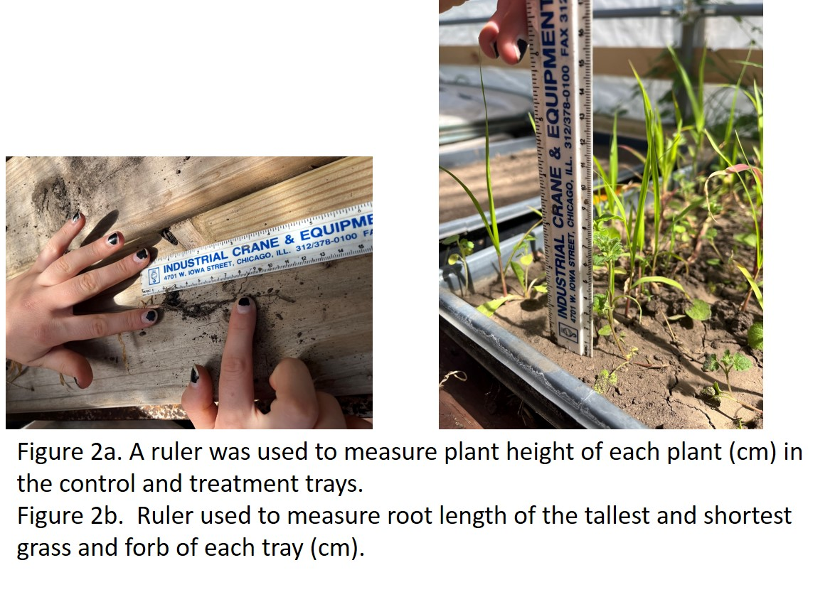
ROOT ANALYSIS METHOD To further observe the growth of the different plants in both the control and treatment trays, we collected data on the general range of root lengths present in the trays. In each tray, we carefully pulled the grass and forb with the shortest and longest above ground height. Then we measured the full length of the root to the nearest quarter centimeter of each pulled plant.
Results
ABUNDANCE RESULTS The calculated average of the number of plants present per control tray is 119.8, while the average per treatment tray is 11.4. We performed an unpaired two sample two-tailed T test on these values, which yielded a P value of approximately 0.000009585538684. Because the two-tailed P value is less than 0.0001, and therefore less than α=0.05, the difference is extremely statistically significant, and we reject the null hypothesis H₀: Garlon will have no effect on Rudbeckia triloba and germination.
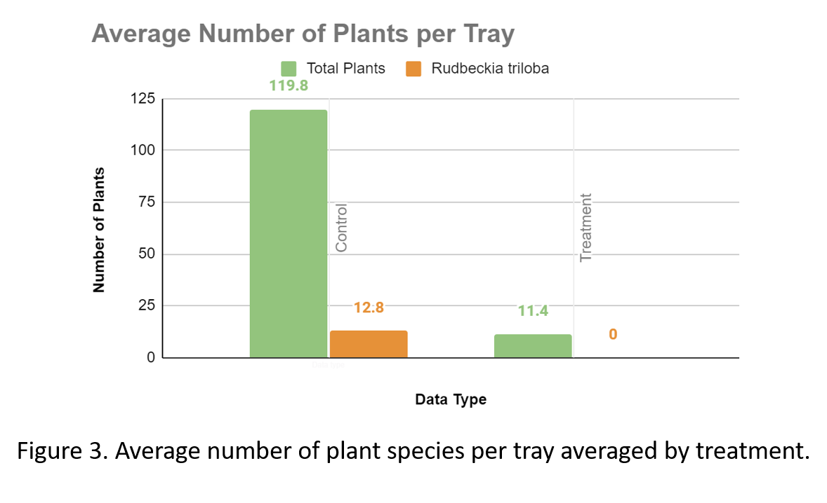
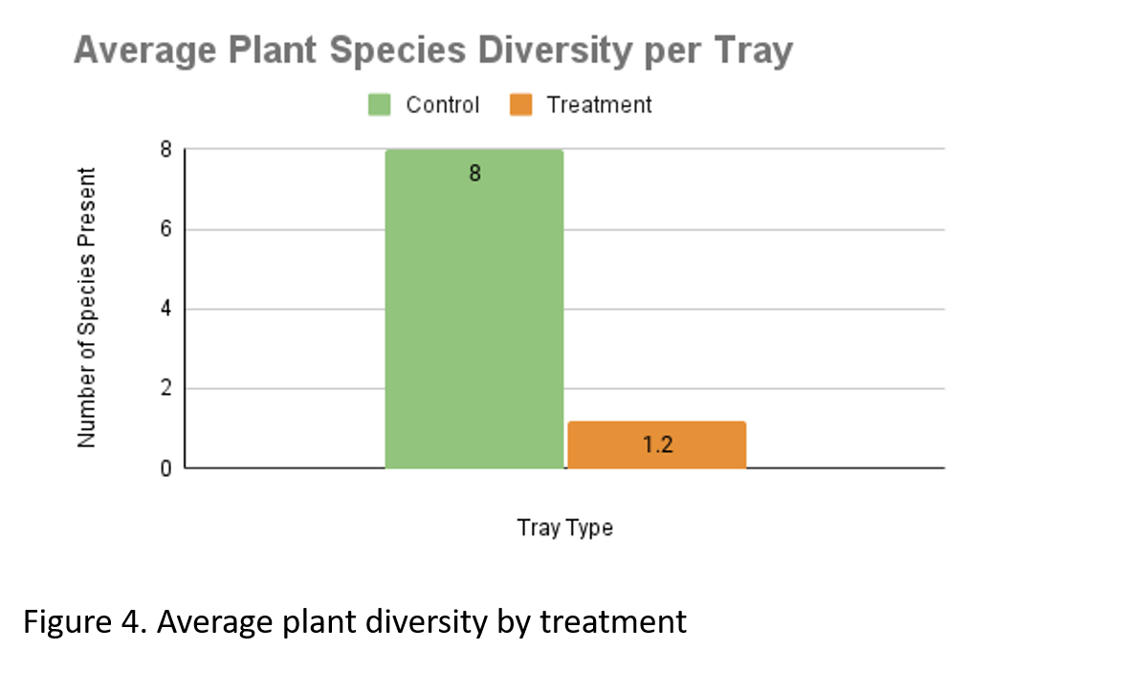
From counting the number of rudbeckia seedlings present, the average number per control tray is 12.8, while the average per treatment tray is 0. Performing an unpaired two sample two-tailed T test on these values yields a P value of approximately 0.0000903582261. Because the two-tailed P value is less than 0.0001, and therefore less than α=0.05, the difference is extremely statistically significant, and we continue to reject the null hypothesis H₀: Garlon will have no effect on Rudbeckia triloba and germination.
DIVERSITY RESULTS The result of the diversity data is the control trays had an average of 8 species present, while the treatment tray had an average of 1.2 species present, indicating that the control trays had more diverse growth.
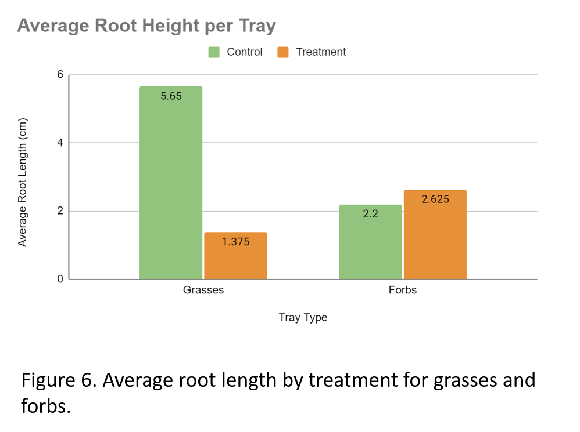
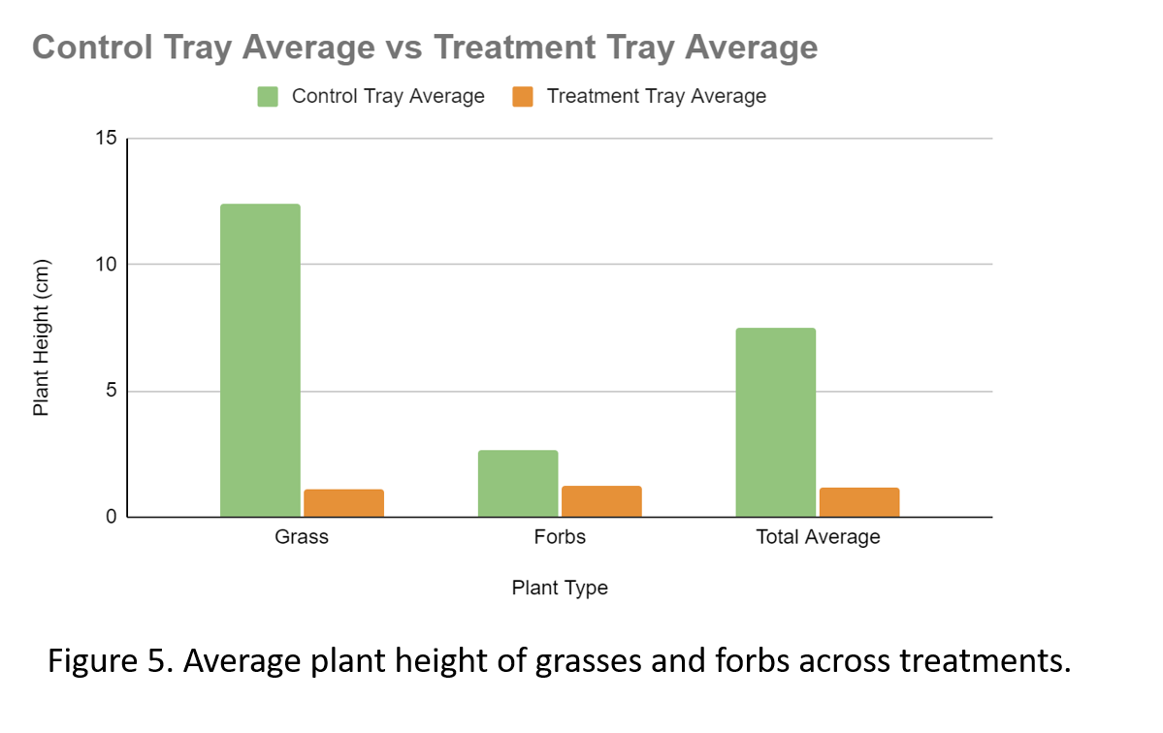
HEIGHT RESULTS The result from the height above ground data is: Plants in control trays grew to an average height of 7.50 cm tall while grass in the control trays grew to an average height of 12.37 cm tall and forbs grew to an average height of 2.63 cm tall. In the treatment trays the average plant height was 1.18 cm, grass average height was 1.11 cm and forbs grew to an average height of 1.25 cm. Overall, the control plants were on average 6.36 cm taller than treatment plants. These results support the H_{i}: Garlon will reduce the germination rate of Rudbeckia triloba germination, and deny the H₀: Garlon will have no effect on Rudbeckia triloba germination.
ROOT RESULTS The plant roots in the control trays grew to an average of 5.65cm for grasses, falling in a range of 1.25 to 13.5 cm. Control forbs roots averaged to 2.2cm in length, in a range of 0.5 to 4.75 cm. The grass roots in the treatment group grew to an average of 1.375 cm, in a range of 0.5 to 3.5 cm. For the forbs in the treatment group no overall average could be calculated because only 1 of 5 trays grew forbs; 2.625 cm was the average forb root length in the single treatment tray. Overall, the control grass roots grew on average 4.275 cm more than the treatment grass roots. Forbs were present in all control trays and only present in one of the treatment trays. Due to the many different species present, the tallest plant taken to sample root length often had shorter roots than the shortest plant sampled. The averaged root lengths merely provide an idea of the range of yielded root lengths.
Discussion and Conclusions
Results of our experiment have led us to reject the null hypothesis that Garlon will have no effect on Rudbeckia triloba. Germination rates observed during our experiment demonstrate that there is a significant difference between the germination of control trays and the germination of those treated with Garlon. Therefore, our prediction is supported in that Garlon treatment reduces the vigor of the planted Rudbeckia triloba.

Future Directions
Going forward, we will test the germination rate of several different native plant species to see if they are affected by Garlon and other herbicides commonly used in restoration. For next year’s experiment we will be using this experiment’s seed and soil to test if the herbicide can persist up to a year.

Works Cited
https://www.arborchem.com/images/label-sds/qa_Dow_Garlon4Ultra.pdf

https://www.invasive.org/gist/products/handbook/20.triclopyr.pdf

https://www.cambridge.org/core/journals/weed-technology/article/evaluation-of-postharvest-herbicide-applications-for-seed-prevention-of-glyphosateresistant-palmer-amaranth-amaranthus-palmeri/359365C80B091223CBC6D91677E25722

https://onlinelibrary.wiley.com/doi/abs/10.1111/rec.12089
https://www.researchgate.net/publication/323375385_Timing_of_seeding_after_herbicide_application_influences_rates_of_germination_and_seedling_biomass_of_native_plants_used_for_grassland_restoration_Timing_of_herbicide_impacts_seed_germination

